# EXPERIMENT NO. 3

**AIM**

To familiarize DDL Commands- ALTER,DROP,TRUNCATE,RENAME

# Questions

1. Create a table emp with attributes empno number(4)as primary key, ename char(10),hiredate, salary,commission and insert the following 5 rows of data

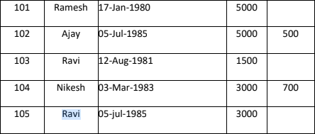

**ANSWERS**

CREATE TABLE EMP(empno INT PRIMARY KEY,ename VARCHAR(10),hiredate DATE,salary INT,commission INT);

INSERT INTO emp(empno,ename,hiredate,salary) VALUES(101,"Ramesh","1980-01-17",5000); INSERT INTO emp(empno,ename,hiredate,salary,commission)

VALUES(102,"Ajay","1985-07-05",5000,500);

INSERT INTO emp(empno,ename,hiredate,salary) VALUES(103,"Ravi","1981-08-12",1500); INSERT INTO emp(empno,ename,hiredate,salary,commission) VALUES(104,"Nikesh","1983-03-03",3000,700);

INSERT INTO emp(empno,ename,hiredate,salary) VALUES(105,"Ravi","1985-07-05",3000);

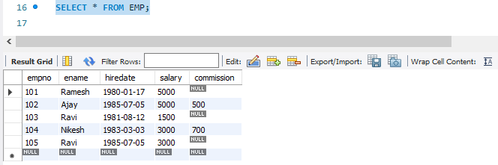

1. Add check constraint (Salary <=5000)

ANSWERS

ALTER TABLE emp ADD CHECK(salary<=5000);

1. Add Check Constraint (length(empno<=3)) Answer

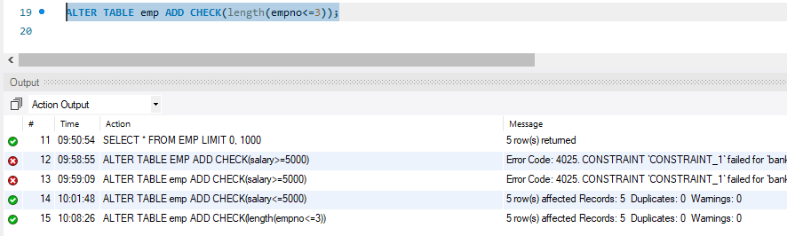ALTER TABLE emp ADD CHECK(length(empno<=3));

1. Modifying the structure of tables a.Add new columns: sal number(7,2)

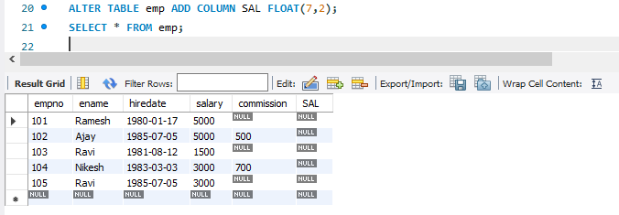

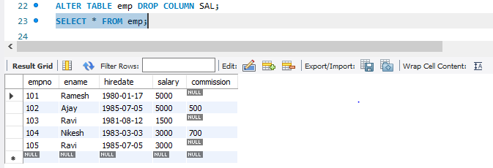b.Dropping a column from a table: sal

c.Modifying existing column :ename varchar2(15)

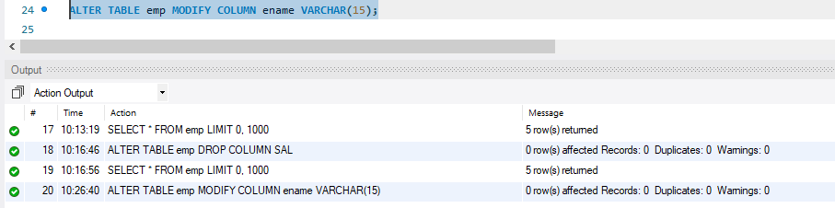

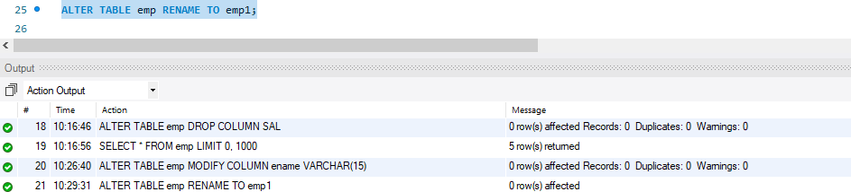d.Renaming the tables: emp to emp1

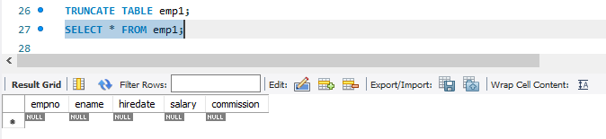e.truncating the tables:emp1

f.Destroying tables:emp

